L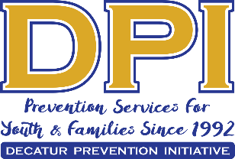
COALITION MEETING
May 5, 2020
1:00 p.m.-2:30 p.m.
Zoom Meeting

AGENDA

- WELCOME WITH VISION AND MISSION (poll)

- MEMBER AND GUEST INTRODUCTIONS

- MEMBER SPOTLIGHT-DECATUR EDUCATION FOUNDATION

- CLOSE-OUT STATE TARGETED RESPONSE GRANT-K. WILSON

- SAMHSA’s National Prevention Week-Contest

- DEFINING ILLICIT DRUG USE/PARTNERSHIP FOR SUCCESS GRANT(chat input)

- Partner Updates-Upcoming Events/Closures

- Individual Strategy Updates & Polls

- Parent Network Update-Parental Perception Poll and suggestions for next session

- How to get our message out?

- Youth action team-alternatives

- Public Service Announcements-Spring Break, Modeling, and Social Hosting

- Suggestions for CR interviewees & Young Adults

Next meeting: June 2 @ 1:00 Virtual

