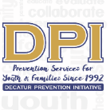

COALITION MEETING

June 13, 2023

12:00 p.m. 1:30 p.m.
Please put your name and your affiliation in Chat
- WELCOME WITH VISION AND MISSION
Vision-Promote a healthy Decatur, free of the negative effects of alcohol and other drugs on youth and families. Mission- Systematically implement evidence-based strategies to promote the behavioral health of youth and families.
- Introductions-Name, Agency Affiliation, Sector-Reminder
Meredith McCoy (Parent), Gary Menard (Health), Duane Sprull (Schools), Brian DiNapoli (Faith), Ladarious Brown (College), Juan Navarrete (SA Prevention Organization), Joe Lee (Business), Dave Nelson (MH Treatment), Alana Smith (Health), Susan Morley (DPI), Dee Anderson (DPI), Carol Treible (DPI), Tiffany Cuthbert (DPI), Terrie Moore (DPI)
- Have you completed the survey? https://www.surveymonkey.com/r/DPICoalition
- Other Upcoming Collaborations- Career Academy Health Experience (Rising 9th-10) July 10⁻ 14 Others
  - DPI will be doing 'Too Good For Drugs' and 'All-Stars' for the Health Experience.
- DHS 101-August 12th Save the Date
  - First 101 since the pandemic, an event for new families (incoming first-year students and transfers) that gives you an overview of what happens at DHS. This event includes reviewing the IB program, techniques to support students, information from current students, break-out sessions, and upcoming coffee chats. The PSA coordinates this event, but the entire school supports it.
  - DPI will table at the event.
  - Duane Sprull will reach out with additional needs for the 101 events,
- Opioid Response Funding- Perdue Pharma Settlement-City of Decatur received a small portion of funding
  - Gary Menard- The amount of funding is not enough to support recovery. The team is shifting to provide Narcan and resources for prevention education.
  - The coalition membership discussed funding utilization, the purpose of Narcan, and sustaining individual strategies. Terrie will share with interested Coalition members.
- GSHS Data is Out!
  - Slight increase in 30-day alcohol use, binge drinking, and marijuana use holding steady. Vaping increased by 1% but is still dramatically down from 2019.
- -STOP Act: Targets for 12-20 (Alcohol ONLY) Support from Ashley Watson and Ladarious Brown
  - Graduating Senior handbook for DHS and ASC-Terrie and Ladarious
  - MOU with ASC-Partnership
  - College Action Team-Ladarious
    - Five members of the team trained. Their proposed name is Peer Health Ambassadors (PHA).
      - The team created a tentative logo, and Ladarious is working to digitize it.
        - Tiffany will see what support may be needed on her end.
      - The PHA team is excited about the Sticker Shock Campaign
      - Two additional individuals are interested in joining PHA this fall.
  - Alcohol info for dorms (poster)
  - Discussing consequences for violations
  - Sticker Shock campaign w/College Action Team-Fall (2 retailers-fall)
- Partnership for Success 14-24 (Alcohol & Illegal Drugs)-thru Sept 2024
  - PreVenture completed for the year.
    - Primarily 9th graders-10 groups-108 invited to participate.
  - Results of Facebook Ad for National Fentanyl Awareness Day-
    - May 9th –22,464 Impressions. Fifty-eight visited the website. 26% Click Thru Rate
    - Big for ages 18-34, and the male population
  - Naloxone Ad
    - Currently running for two months at North Dekalb and Madison Yard AMC
- ASC Survey-
  - DPI- IRB submitted but has not received additional information yet.
- Freshmen Orientation event – August 19th
  - DPI is considering doing drunk goggles and Harm Reduction techniques—drink covers, etc. There is only an hour's time frame for this.
- LGBTQ+ Community- ASC
- Drug-Free Communities 9-18 (Alcohol, Nicotine, Marijuana)-Thru Sept 2024
  - Got Outcomes Application-Thanks for support-Due June 30th-Marijuana Focus
    - Reapplying as a Blue Ribbon Coalition
    - Thank you to the coalition for completing the survey and giving us some informative feedback for the application process.
- Last Year-ends Sept. 2024
- CMAT Recent & Upcoming Events-Dee
- YAT-Members Report-Marnie
  - Marnie is recruiting new members. The YAT recently had a vaping ad which was DPI's first time having a single-frame ad (Think poster).
  - Snapchat analytics indicated 22,400+ Impressions. One hundred eighty-one visited the website. 0.73% Click Thru Rate> Highest CTR ever.
- The Biggest Influence #2 Ad to air this week-Target audience is parents.
- EBP-All Stars Annual Summary-Marnie
  - Finished up the year with 120 students.
- Prevention Plus Wellness (all DHS health classes-April)-Summary Attached
  - Finished up the year with 372 students.
- Focus Articles for DPI and Network Volunteers Needed
- At-A-Glance Evidence-Based Programs-"
- Safe Homes "Decatur Parents Network."
- All Stars-7th grade Wellness Class-Marnie
- Prevention Plus Wellness 9th-Susan
- This Is Not About Drugs
- DPI is considering piloting" Safe Talk," a harm reduction program for high school students.
  - DPI is considering launching (DHA) the 5-session program and getting participants to look at their belief systems with marijuana.
- PreVenture-Screening-Can This Expand to Other Grade Levels?
- Parent Handbook for Graduating Seniors (Penn State version)
  - Parent Handbook has been sent out twice, and DHS will send it one additional time. DHS had 440 graduates, and 180 have viewed the document. DPI can track through the Parents Network and Dpi website.
  - ASC admissions will share the parent handbook with the incoming Class 2027 for Agnes Scott. The emails are scheduled for June 27th, July 31st, and August 17th.
    - Agnes Scott College will provide Alcohol EDU training with the Parent handbook.
  - The handbook is evidence-based, and DPI has a one-year license to encourage parents to have the needed conversations about substance abuse upon graduating high school or entering their first year of college.
NEXT MEETING: July 11th @ 12:00

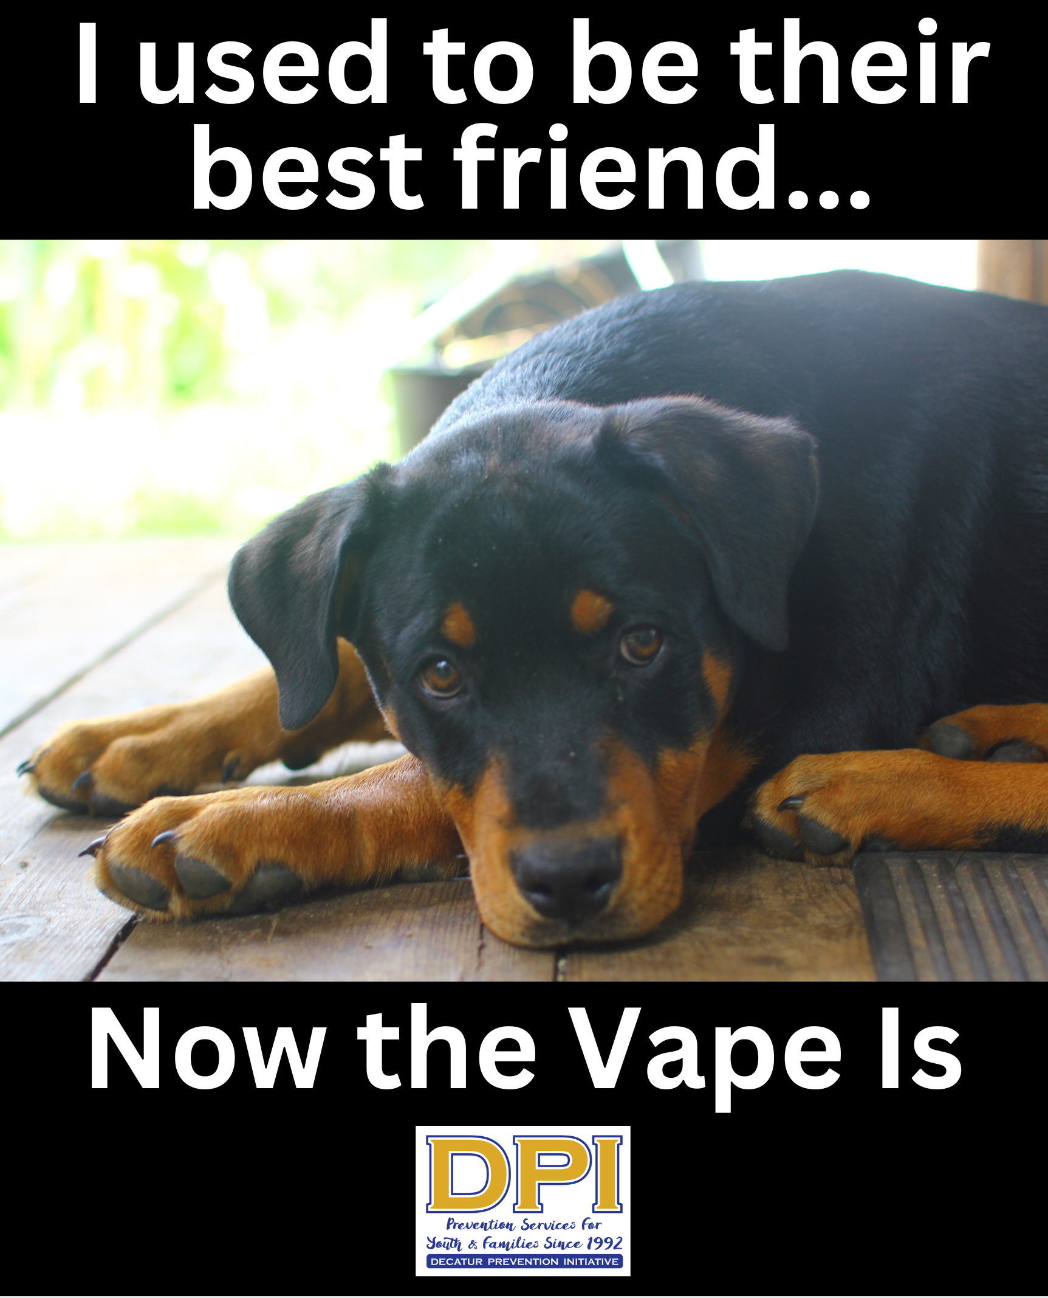
Developed by YAT member Justice with MG support-Will, be geotargeted with SocialMedia.
2023 Prevention Plus Wellness-9th grade Health

The completed surveys for the 2022-2023 year included 372 pretests and 366 posttests.
The most compelling pre-posttest data are from the measures of perceived harmfulness of individual substance use.
There was an increase in the percentage of Prevention Plus Wellness program participants across all five substances measured who reported that using each of the individual substances would harm their health or health habits "a great deal."
These increases ranged from 7% for e-cigarette and opioid use to 9% for alcohol, 10% for smoking cigarettes, and 11% for marijuana use.
In addition, at the post-test, most participants reported it would be "very unlikely" for them to try each of the 5 substances measured.
Those who reported they would not use them next year ranged from 53% for alcohol and 66% for marijuana to 75% for e-cigarettes, 80% for regular cigarettes, and 84% for opioids.
Over 6 in 10 (64%) also said they would get physical activity most days a week in the next year.
Participating youth reported they liked many aspects of the PPW lesson, including the following sample comments:
- I learned a lot.
- It taught me a lot about motivation.
- It helped me learn about health behaviors and goal setting.
- It helped raise awareness about the dangers of drug use.
- It was very informative.
- The teacher was great.
- I liked how it had ways to improve your life and stay healthy instead of only saying no to drugs or alcohol.
- I liked learning about avoidance techniques.
- I liked learning the consequences of drugs.
- It was good motivation.
- I liked how we talked about how to say no.
- It made me realize how much I can control my future and how going along with the crowd isn't necessary when your health is in question.
- The slides.
- It allowed me to learn about good decision-making and how I want to improve my health.
- Helped me set health goals.

Parent-Teen Partnership Handbook

Table of Contents

Introduction ....................................... 7
Improving Communication in General ................ 8
Communication Pointers ............................ 10
The Initial Conversation ............................. 11
Communication: The Short Response.................. 12
Developing Assertiveness ............................ 13
Talking About Alcohol............................... 14
How Alcohol Works in the Body ...................... 15
Why Students Drink................................. 17
Why Students Do Not Drink.......................... 19
Binge Drinking: Drinking to Get Drunk ............... 21
Did You Drink When You Were a Student? ............. 23
For More Information ............................... 25

