COALITION MEETING
January 12, 2021
1:00 p.m.-2:30 p.m.
Zoom Meeting
AGENDA
Please put your name and your affiliation in Chat
- WELCOME WITH VISION AND MISSION
Vision-Promote a healthy Decatur, free of the negative effects of alcohol and other drugs on youth and families.
Mission: Systematically implement evidence-based strategies to promote the behavioral health of youth and families.
- MEMBER SPOTLIGHT-DeKalb CSB Mobile Telehealth Clinic (Janel Allen)
- Sustaining our Successes-Carol Treible
- Partner Updates & Opportunities for Collaboration-Please put dates and links in the chat.
- A new issue across all grants (underage drinking)-
Open Container Ordinance extended Original Here and extension
- SAMHSA Partnership for Success Grant-2024 (14-24 y.o./ underage drinking, opioids, stimulants+)
-Overview: What to do with a level “3” Levels
-Current PSA’s- Every Day Counts 12/20-1/20 Here
-Idea Engineering-Illegal Drug Campaign
-EOY report-Accepted and Uploaded
- New Survey
- CDC DFC Grant-2024- (18 & under/ alcohol, nicotine, and marijuana)
Positive Social Norms, Access, Policy
- DBHDD ASAPP-2021 (9-18 Underage Drinking and partial RX use
Tobacco PSA Results & Carpe diem AD (attached)
-All Stars Core – Recruitment/Potential Sites
- Parent Network Feedback: https://www.decaturparents.net/
-Leadership Team leaders needed
-December Event-Parenting Under Pressure Part 2
-What’s Next
DHS PTSA liaison-Youth Events
- Scavenger Hunt Announcement-6 Middle School Winners
- End of Year Celebration-Thank you to Kimberly and Todd.
- Next meeting: February 9th (2nd Tuesdays @ 1:00)

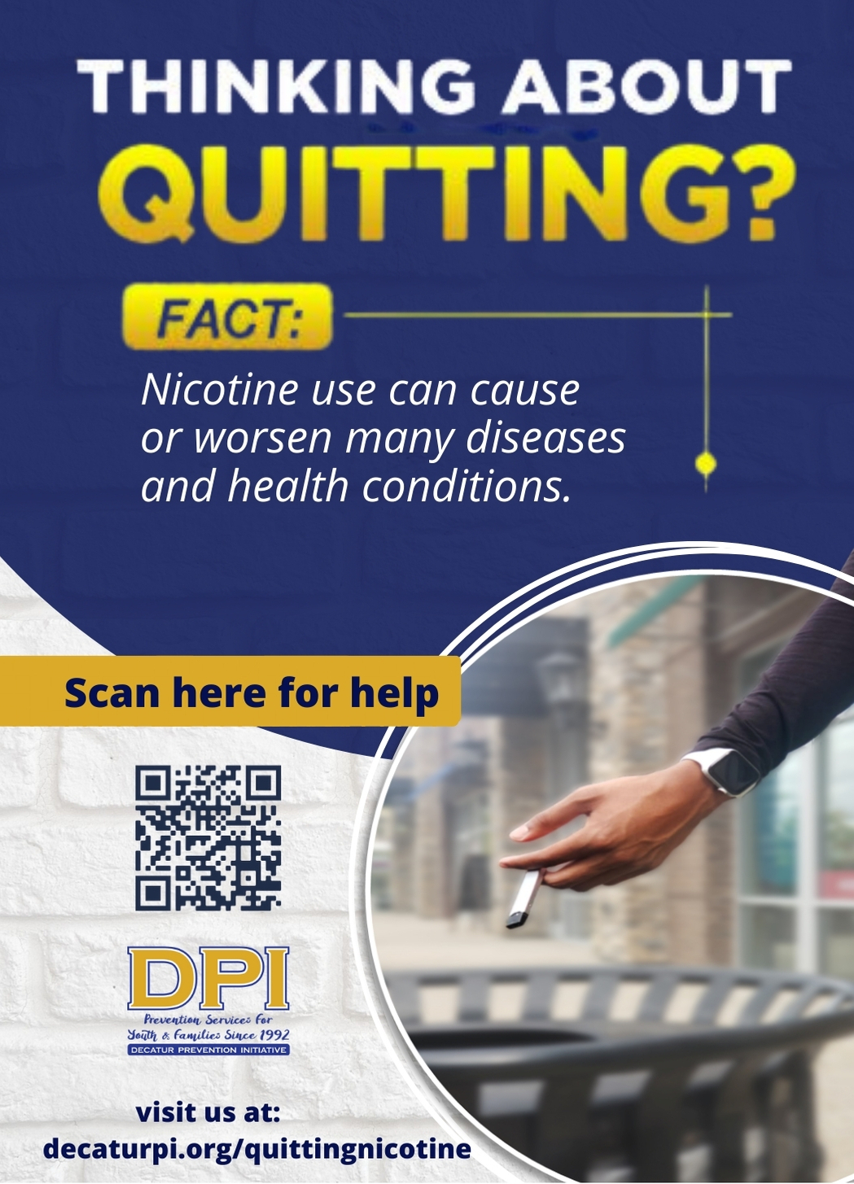
Coalition Meeting Notes: January 12, 2021, 1:00pm – 2:30pm
Virtual Zoom Meeting
Attendance (13): A total of 13 participants attended the virtual zoom meeting. Attendees were Ashley Simpson, Xylina Jenkins, and Janel Allen(DeKalb Community Service Board-Government Agency SA Treatment), Corey Bivens (Decatur Housing Authority-Youth-Serving Org), Myra Chao (DeKalb Community Service Board-SA Prevention Agency), Devon Johnson (Emory Center- MSAACD-Health), Joel Gould (Carrot and Stick-Local business), Stacey Stevens (Clairmont YMCA/Decatur-Rotary-Civic Org), Dianne Andree (City Schools of Decatur Student Center-Schools) Kimberly Wilson (GUIDE, Inc. SA Prevention Agency), Carol Treible (DPI-Evaluator), Marnie Grodzin (DPI DFC PC/Youth Development), and Terrie Moore (DPI Executive Director). No sign in due to the virtual venue. DPI virtual meetings are typically recorded and stored for the short-term until minutes are produced. This month there was a technical error, and our assigned notetaker was absent. Notes will be more sparse this month.
Start: 1:02 pm End: 2:45 pm
Notes provided by Terrie Moore
Welcome/Introductions: DPI Coalition will continue to meet virtually due to the Coronavirus pandemic. Terrie Moore welcomed coalition members, and members read the vision and mission. Those present introduced themselves and their affiliations.
Member Spotlight: The DeKalb Community Service Board was our spotlight agency at this meeting. Janel Allen spotlighted a new service that will be launching next month. The "Mobile Telehealth Clinic" is being established in the county and will have specific contracts to provide their services in Decatur with many of our partner agencies. They currently have three vans, funded through a grant by the CARES Act. Currently, there are negotiations for a contract at Clairemont Elementary and the Decatur Housing Authority. Other sites were also mentioned. All that is needed is a parking space. The vans will allow for telehealth services and assessments. DPI hopes to provide some literature for the vehicles as well. Terrie mentioned that she would link Janel with Jen Walcott, who works very closely with the downtown homeless community. The Metro YMCA's are also working with this service. If you want more information, please reach out to Janela@dekcsb.org
Sustaining Our Success: Terrie Moore once again shared some of our successes. DPI's goal for the 5-year ASAPP grant was to lower HS underage drinking by 20% from 30% use to 24%. The current data shows that DPI exceeded the goal, and the rate is currently at 22%. Another long-term goal was to lower the onset of alcohol use by high school students from 20% to 15%. The data indicates that the rate is 16%, a percentage of lowering our goal by 20%.
Carol Treible then led us in a discussion about sustainability and Moving Forward. She called for input in the following areas: 1) Human Capacity, 2) Financial Resources, 3) Materials, and 4) Technology.
Partner Updates and Opportunities for Collaboration –
- Stacy shared that the YMCA has a pilot project for 13-18-year-olds (civic engagement project). She will forward the flyers to our mailing list after the meeting.
- Devon (Emory) shared the upcoming training provided by Voices 4 Prevention on January 21. This training includes youth from the Dover Youth-to-Youth project, and youth are invited to attend. This training will help prepare Substance Abuse Prevention Day participants at the Georgia Assembly (virtual) on March 9.
- Corey Bivens, DHA, shared that he anticipates being back in the Community Center on January 19. The plan is to initially serve high school students in smaller groups, in compliance with CDC recommendations. They are also considering serving about half of the K-5 in the afterschool program. He also shared that one of the DHA Seniors received the Posse Foundation Scholarship and will attend Georgia Washington University.
- Dianne Andree shared that the Student Center is leading a Senior Grief Group. Contact her for more information. Students are also actively advocating to keep the Wellness Wednesday format while they are in virtual school. The student center has expanded to have services located at Renfroe Middle School. Her department is seeking stakeholder input.
- Myra Chao shared that they received a DFC grant for years 6-10.
- Joel Gould discussed that having soccer continue during the Covid shut-down has been very beneficial for many youth. He also shared that our own Aly Yamamoto was recently recognized in the New Yorker and on MSNBC N advertising in the Carpe Diem. She recently organized a focus group for our PFS grant.

Open Container Ordinance: With an open container temporary ordinance passed in the fall, DPI has been concerned that this may become permanent. As decided at the December meeting, Terrie wrote a letter to the Mayor and had several members review it. Terrie asked if anyone else would like the opportunity to see it before submission. Joel Gould asked for a copy. She is also sharing the letter with the YAT, as they have expressed concern about the impact of open containers on the kid-friendly climate in the downtown area.

SAMHSA PFS Grant- This past month, the annual report was submitted and approved. It is available on our website for review, along with our Community Readiness report. Terrie shared the geo-targeted PSA's success and shared the link for the most recent campaign, Every Day Counts. All PSA's are now on our YouTube channel. The PFS partners will be working with Idea Engineering to develop an Illegal Drug Campaign targeted at Young Adults. This contract includes a separate website to provide age-appropriate content. DPI continues to reach out to Agnes Scott College. Carol Treible and Tyrone Bell are developing a new survey to help with the needs assessment.

CDC DFC Grant: DPI has prepared a Positive Social Norms campaign to be displayed around the community. We are also reaching out to law enforcement regarding compliance checks and enforcement issues. Carol and Terrie led a discussion of the changes for collecting our Core Measures due to the GSHS not being mandated this year. An alternate survey is available through GA DOE, but unsure if City Schools of Decatur will participate. Terrie will work with Duane regarding the collection of this data. Thankfully, we have our baseline data entered, and the next data input is not required until 2022.

DBHDD ASAPP- Results of the 2A's and an R campaign were shared. It seems we had a significant increase in traffic to our resources page, but many by-passed the embedded survey. Marnie continues to search for youth participants for the All Stars Core program. It is hoped that the Community Center may provide such an opportunity and possibly a local private school. The CDC requirements make it difficult to reach youth in person, and many parents report that youth are burned out on virtual programs. The Parent Network December event, Parenting Under Pressure-Part 2, was well received. Another speaker event is being planned for February. The PTSA did not meet in December. However, our DHS PTSA liaison shared the upcoming youth events.

Scavenger Hunt: Six local winners were announced. They received gift cards to Chik Fila for promoting our positive social norms messaging.

Member Recognition: The December appreciation event was a great success. Terrie thanked Marnie Grodzin, Kimberly Wilson, and Troy Ernest for being on the event committee and making a fun virtual event. If you haven't done Troy-style Bingo, you are missing out.

Next Meeting:– Virtual on Zoom: February 9 at 1:00 pm (2nd Tuesdays)

