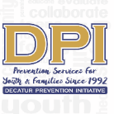

COALITION MEETING

April 11, 2023

12:00 p.m. 1:30 p.m.
Please put your name and your affiliation in Chat
- WELCOME WITH VISION AND MISSION
Vision-Promote a healthy Decatur, free of the negative effects of alcohol and other drugs on youth and families. Mission- Systematically implement evidence-based strategies to promote the behavioral health of youth and families.
- Introductions-Name, Agency Affiliation, Sector-Reminder
Shonda Moore (Schools), Duane Sprull (Schools), Lartesha Chaney (Youth-serving organization), Mutasem Shopson (SA Prevention Organization), Janel Allen (Gov't Agency-CSB), Stacey Stevens (Civic Org), Dianne Andree (Schools), Ninetta Violante (Gov't Agency-Health), Madeline Pappas (Youth), Ashley Watson (Epi- Support), Marnie Grodzin (Youth Outreach), Tiffany Cuthbert (Admin Support), Dee Anderson (Parent Outreach), Carol Treible (Evaluator), and Terrie Moore (Director)
- Evaluator Report
Carol Treible-
- Drug-Free Community Grant- First three years and currently in 4th year of this grant
  - Implemented a total of 1,982 Activities for the grant thus far submitted in August 2022
  - Information Dissemination- 1784 different activities. Very active in media coverage, social networking for 74 different strategy activities, the website for 15 different strategy activities, and media coverage for 12 different strategy activities.
  - Enhancing skills- Participated in 161 different activities. YAT and CMAT training activities have the most significant impact on the success of the overall goal.
  - Provide support in 15 different social activities.
  - Changing physical design- 7 different activities with specific emphasis on alcohol and tobacco-free zones
  - Changing consequences- 8 different activities within improving access, reducing home and social access to alcohol and other substances
  - Education and informing about modifying and changing policy- worked on drug-free schedules and outlook activities.
  - Congratulates the DPI coalition on substantial diversity and sector representation.
    - Terrie Moore will send a link to an anonymous survey to receive feedback on the Community Coalition. Send a separate email saying it has been completed, and you will be entered into a drawing for an Amazon gift card.
- Other Collaborations-
  - DEA Take Back Day April 22 (Avondale?)
    - Nothing has been scheduled for Decatur due to stretch thin with resources of officers but were told to direct individuals to Avondale.
  - Screenagers Premiere-April 24-
    - Atlanta Premiere hosted by DPI. The filmmaker will be in attendance.
      - Monday, April 24. Doors open at 6:30 P.M., and the movie starts at 7:00 P.M.
        - The panel will immediately follow with four panelists.
        - Please share with your various communities
        - Tiffany will update the promo and send it to everyone after the meeting.
  - YMCA Kids Health Day- April 29
    - Stacey Stevens- Healthy Kids Day at all locations- Always seeking volunteers. Sending information to Nurse Moore to recruit more volunteers. DPI will have a table, and Stacey will send out the promo for the event and call for volunteers.

  - Career Academy Health Experience (Rising 9th-10) July 10⁻ 14 Others
    - Nurse Moore- Wellness Camp and Career Academy - DPI is partnering and will discuss further offline.
  - Housing Authority
    - Lartesha Chaney- Excellence Awards are coming up, and interviewing for LITs. Will send Terrie the LIT schedule and more information on the awards and the graduates.
  - DeKalb Community Service Board
    - Janell Allen- First Week in May is Children's Mental Health Week (May 1st -7th for Georgia, May 8th-13th Nationally).
      - Georgia Parent Support Network for local events
      - Capitol event at the Georgia Freight Depo on May 4
      - APEX Summer Camp is coming up for rising 3rd – 8th grade.
  - Decatur Career Academy
    - Duane Sprull- 515 9th grade students, 435 Seniors at DHS
      - Prom on the 20th
      - AP testing is coming up soon and may need support around Mental Health
      - Terrie Moore- Handbook to parents of graduating Seniors. Researched to be effective if sent to Parents right before graduation.
        - Duane- No longer has data the following week when school is over. So the sooner we get it out, the better.
  - Decatur High School
    - Nurse Moore- Working with Menard to get the entire Superintendent staff and administrators trained in Narcan.
      - Marnie- Nurse Moore will be the first on our Facebook page to celebrate our CPAW members. Check it out to see the post.
        - Please respond to our link so that we can celebrate you - https://forms.gle/fwqmeLeoXW3L6PUz8
- -STOP Act: Targets for 12-20 (Alcohol ONLY) Support from Ashley Watson and Ladarious Brown
  - Graduating Senior handbook for DHS and ASC-Google Translate
  - DUI events (Cinema Drive Postponed for early fall)
  - Upcoming College Action Team and Training April 15-Ladarious/Lauren
  - PSA- Honor Court-Airing now
  - MOU with ASC-Partnership
  - Sticker Shock campaign w/College Action Team-Fall (10 retailers)
- Partnership for Success 14-24 (Alcohol & Illegal Drugs)-thru Sept 2024
  - PreVenture completed for the year (10 groups-108 invited to participate)
- ASC Survey Report completed.
- Deterra Distribution-Any need
- Harm Reduction? Drink covers, etc.
LGBTQ+ Community
- Drug-Free Communities 9-18 (Alcohol, Nicotine, Marijuana)-Thru Sept 2024
- Last Year-ends Sept. 2024
- CMAT Recent & Upcoming Events
  - Dee Anderson- The latest CMAT meeting was on March 28th meeting on Zoom.
    - Oliver House Community Flea Market and Festival on April 22
    - DHA hosted the Annual Easter Egg drug-free hunt on April 30. CMAT participated.
    - End of the month- Seniors at Oliver House will do the Sassy Senior Fashion Show

- Talk They Hear You PSA before spring break.
  - Geofencing through social media advertising. Recent campaign 'Talk, they Hear' 30-second ad campaign for Decatur launched right before Spring Break to flow into Alcohol Awareness Month targeting parents. Still running-
    - 19758 impressions, 84 click-through rates, and good ROI with an estimated $500.
- Parent Network-Screenagers: Under the Influence-Vaping Drugs and Alcohol in the Digital Age
- April is Alcohol Awareness Month-Proclaimed by City
- YAT-Members Report
  - Marnie Grodzin- Applications for the DYAT are opening up, and members will have to re-apply. Rising 9th-12th grades at Decatur High School
    - All youth who want to join must prioritize time and the team.
  - Madeline- DYAT received a proclamation declaring April as Alcohol Awareness from the Mayor and City Commissioner. Opportunity to speak on the DYAT goals and provide swag.
    - Environmental Scans- Going around the City of Decatur business district and noticing the community advertising, placement, and messaging. Scanning helps us understand the City's culture and see what it looks like as we approach 420.
- EBP-All Stars (round 3) & Prevention Plus Wellness (all DHS health classes-April)
- Focus Articles for DPI and Network
- At-A-Glance Evidence-Based Programs-"
- Safe Homes "Decatur Parents Network."
- All Stars-7th grade Wellness Class-Marnie
  - Halfway through, and will end up with 46 trained at the completion.
- Prevention Plus Wellness 9th-Susan
- This Is Not About Drugs
- PreVenture-Screening-Can We Expand?
- Parent Handbook for Graduating Seniors (Penn State version)
NEXT MEETING: May 8 @ 12:00

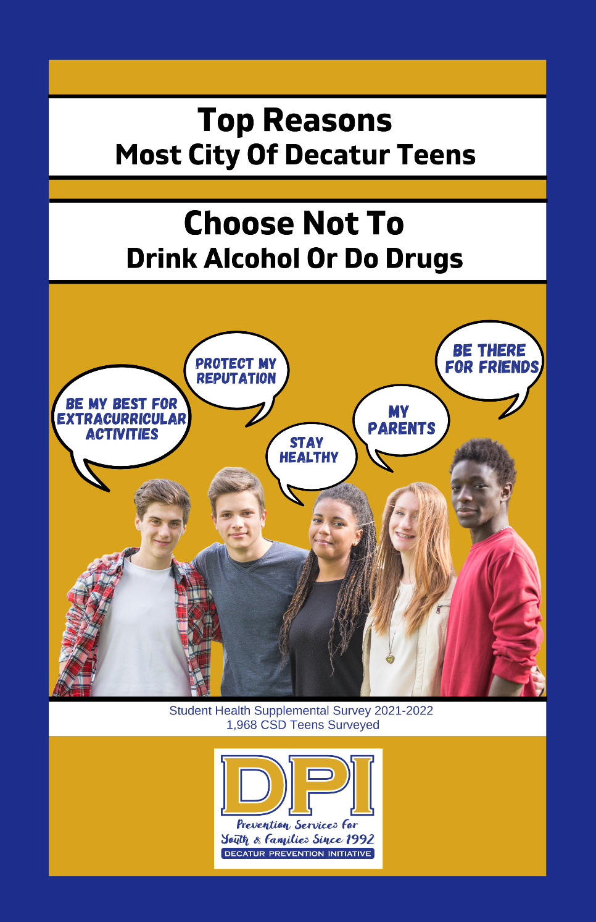
Presented by the Youth Action Team to the City Commissioners

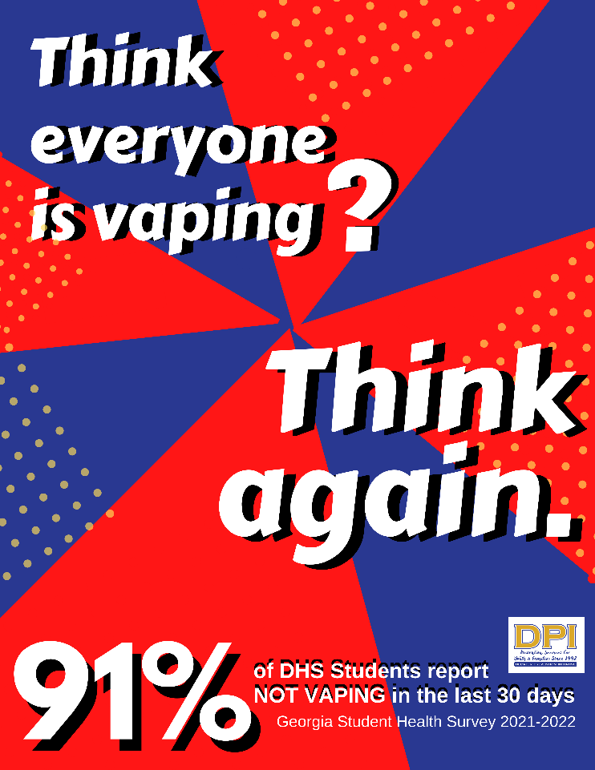

Parent-Teen Partnership Handbook

Table of Contents

Introduction ....................................... 7
Improving Communication in General ................ 8
Communication Pointers ............................ 10
The Initial Conversation ............................. 11
Communication: The Short Response.................. 12
Developing Assertiveness ............................ 13
Talking About Alcohol............................... 14
How Alcohol Works in the Body ...................... 15
Why Students Drink................................. 17
Why Students Do Not Drink.......................... 19
Binge Drinking: Drinking to Get Drunk ............... 21
Did You Drink When You Were a Student? ............. 23
For More Information ............................... 25

