L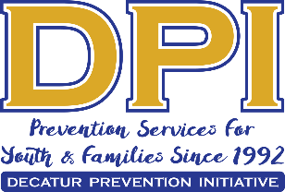
COALITION MEETING
March 3, 2020
1:00 p.m.-3:00 p.m.
Decatur High School-Hospitality Room
310 W. McDonough Street

AGENDA

- WELCOME WITH VISION AND MISSION
- APRIL MEETING?
- MEMBER AND GUEST INTRODUCTIONS
- SPECIAL PRESENTATION: “Don’t Run, Call 911”
- GA’s Medical Amnesty Law and Expanded Naloxone Access Law
Laurie Fugitt, R.N., B.S.N
Robin Elliott
Cofounder, Georgia Overdose Prevention
- Survey
Carol Treible: DPI Evaluator
- Partner Updates-Upcoming Events
- Parent Network update
- Update on GSHS Survey
- Need for Young adults to do survey
- Upcoming PSA-No Regrets Spring Break
- Suggestions for CR interviewees
- Upcoming Events
Mayoral Proclamation: March 16-Meet at City Hall @ TBD PLEASE COME AND SHOW SUPPORT
- Let’s Talk About Drugs: A Family Discussion 6 pm, March 5 @Community Center
- Oliver House Safe Storage Training 4:00 DYAT
- DJJ Youth Summit, March 21, St. Phillips AME-All-Day (flyer to be sent)
- Free ASO Community Concert at Agnes Scott @ 4:00 (reserve tickets)
- March 14-Gathered and Grounded-LGBTQ+ Event
- April 23-Cinema Drive for General Public 4:00-5:30
- Proposed Parent Network Event March 24 or 31- Asst. DA on Teen Safety

