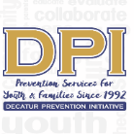

COALITION MEETING

January 9, 2024

12:00 p.m. 1:30 p.m.
Please put your name and your affiliation in the Chat
- WELCOME WITH VISION AND MISSION
Vision- Promote a healthy Decatur, free of the negative effects of alcohol and other drugs on youth and families. Mission- Systematically implement evidence-based strategies to promote the behavioral health of youth and families.
- Introductions: Name, Agency Affiliation, Sector-Reminder -Expanding Sectors and preparing for the next round of funding opportunities with CIA and Letters of COMMITMENT- collecting.
Duane Sprull (Schools), Gary Menard (Fire Dept-Govt Agency), Alana Smith (Health), Lartesha Chaney (DHA-Youth Serving), Ramsay McWhirter (YMCA), Stacey Stevens (Rotary), Corey Bivens (DHA-Youth Serving Organization), Trang Vo (SA Prevention Organization), Stevette Watkins (Veterans Affairs-SA Prevention Organization), Janel Allen (DeKalb Community Service Board-MH/SA Tx), Yari M (SA Prevention Organization), Ashley Watson (DPI), Jackie McKie (DPI), Dee Anderson (DPI), Tiffany Cuthbert (DPI), Terrie Moore (DPI)
- Opportunities for Collaboration/ Any Training Requests

- Sustainability? Opioid Settlement? Naloxone Distribution
  - Captain Menard's goal is prevention, harm reduction, and open parameters. Naloxone was purchased and distributed to school bus drivers, Agnes Scott Resident Advisors, multiple businesses, Sycamore Street Church, and Oliver House Seniors. The goal is to get it throughout the community. Terrie suggested Charis Book Store as a site because they host many LGBTQIA+ support groups. YMCA staff also received Naloxone and training through DBHDD (Thanks, Alana).
  - DEA numbers are going up in terms of fatal doses of pills found on the street. The numbers have increased from 6 out of 10 pills to 7 out of 10 (Anticipate another increase soon.) The DEA reports this is most common in Xanax and Percocet counterfeit pills. However, a Gwinnett school reported an overdose (not fatal) with vapes.
    - Considering a campaign for the entire community- Buyers cannot tell if it is a real pill unless purchased at the pharmacy.
    - A local bar in Gwinnett had nine overdoses in one night. Luckily, there are no fatalities, but counterfeit drugs are showing up in everything lately.
- Cinema Drive-Scheduled April 10 and 11th.
  - Cinema Drive is an engaging production funded through the GA Department of Highway Safety. DHS will host on April 10th and 11th during the school day, with the target audience being seniors.
  - DPI will potentially offer it to the community on April 10th after school. Principal Sprull will look into this further and get back to Terrie.
  - Agnes Scott has scheduled Cinema Drive for late afternoon on February 28.
- TINAD for this year?
- Mental Health-DHS Coffee Chat-11/30 with Student Center
  - Completed
- GSHS Supplemental Surveys-In process
  - Principal Sprull will get someone to help facilitate the Supplemental Survey this year to ensure that students complete all surveys. The goal is 75% of each grade.
- YMCA opportunities & Parent Network Suggestions (after winter break)

- STOP Act: Targets for 12-20 (Alcohol ONLY) Support from Ashley Watson and seeking new interns.
  - Sticker Shock campaign w/College Action Team-Suggestions for Next Retailers
  - DUI Ad-Carpe Diem and Snapchat
  - College Handbook for DHS and ASC-May
    - DPI plans to replicate this campaign this year.
  - College Action Team-
    - Begin again this month.
  - Discussing intervention
  - Reaching Parents and Middle School re: Impaired Driving?
- Partnership for Success 14-24 (Alcohol & Illegal Drugs)-thru Sept 2024-
- Reapplying for Decatur/Dekalb-Letters and Ideas are needed.
    - DPI proposes potentially expanding into targeted areas of DeKalb County and expanding the ages served. The grant will help address the gaps using the SPF process.
    - Janel Allen- Looking into addressing the gap for underserved adolescents, focusing on substance use outpatient opportunities. Lack of funding. PFS may not be able to cover this, but DPI will potentially investigate more ways to address this area for the adolescent/ young adult population.
    - Captain Menard got some of the Coroner's information, and Alana is looking into the opioid area and when the needs assessment will be released.
  - Community Readiness Report-
    - Stage 4- illicit substances.
    - DPI is not aware of another organization that covers the entire DeKalb area.
  - PreVenture-Screening completed (110) Groups completed 4 Groups
    - Led by Susan Morley and Sara Gheesling-Obtaining Parental Permissions- generally at most 10 participants.
    - Consider an after-school option once a week to expand.
  - TINAD-BHMS Wellness Classes- 2 8th grade classes & Sched for 2nd semester
    - Susan is interested in adding this to PreVenture and will discuss it further with Principal Sprull.
  - Survey Tabling-ASC?
- LGBTQ+ Community
- Ads in Movies
- Completed DUI Ads over Holidays (new resource page) holidays. Ran for over two months and led to decaturpi.org/drivesober
- Ads on Social Media
- Completed and Designated driver ad over Holidays that also led to decaturpi.org/drivesober
- Analytics are 18,000 impressions, 113 link clicks, and 0.61% Click-through Rate.
  - Drug-Free Communities 9-18 (Alcohol, Nicotine, Marijuana)-Thru Sept 2024
  - Two Decatur Parent Network Events-Screenagers and Vaping
  - Request for more vaping presentations to students (DHS?)
    - Principal Sprull said we could consider adding a vaping or substance abuse prevention message into the Morning Announcement daily once a week.
      - Is there a program available for those looking to quit vaping? Not currently, but there are resources available.
  - At the Movies: Madison Yards and North DeKalb 10/6-12/3
  - Blue Ribbon Coalition- Exhibiting at CADCA
    - DPI will present at the National Leadership Forum and showcase the marijuana results in the exhibit hall.
    - DPI's data shows that Decatur is currently seeing marijuana use decrease. DPI will create a large poster that will list partnering agencies.
- CMAT Recent & Upcoming Events-Dee Anderson
  - Twenty-two parents participated in the in-person meeting. It was a great meeting with games, resources, door prizes, etc.
  - The planning stage and meeting will be on January 23rd- Mrs. Dee will reach out to Captain Menard to have resources and do demonstrations.
  - Have DPI members checked the DPI Facebook? Follow DPI at www.facebook.com/Decatur www.facebook.com/DecaturPreventionInitiative
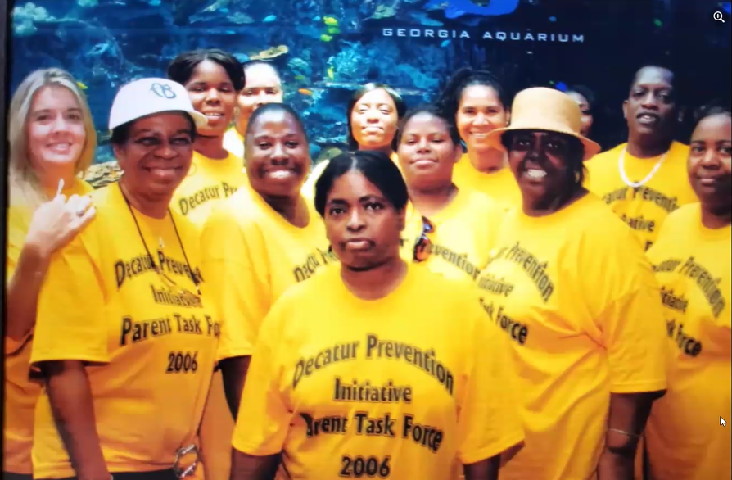

- EBP-All Stars- Fall completed (37 7th graders) 1/10 Spring Semester
- Prevention Plus Wellness- Completed 7 classes and scheduling for Spring Susan Morley
- Annual Appreciation Event-Thanks to All
  - BG Advertising and Carol Treible provided lunch. Thank you so much!

Next Meeting: February 13th Noon

At-A-Glance Evidence-Based Programs-
- Safe Homes "Decatur Parents Network."
- All Stars-7th grade Wellness Class-Terrie
- Prevention Plus Wellness 9th-Susan
- This Is Not About Drugs=Next Offering BHMS
- PreVenture-Screening only in health classes at this time.
- Parent Handbook for Graduating Seniors (Penn State version)

Illegal Drugs Readiness Score-Preplanning
What to do at Stage 4 Readiness?
- Introduce information about the issue through presentations and
- media.
- Visit and invest community leaders in the cause.
- Review existing efforts in the community (curriculum, programs, activities, etc.) to determine who the target populations are and
- consider the degree of success of the efforts.
- Conduct local focus groups to discuss issues and develop strategies.
- Increase media exposure through radio and television public service announcements.

